**Lab 9 AMQP**

Write two AMQP applications:

1. An AMQP Producer for a Direct Exchange –template project provided [AMPQProducer.zip].
2. An AMQP Consumer for a Direct Exchange –template project provided [AMPQConsumer.zip].

The domain object used in the payload is Item from Caveat Emptor…

Both applications have the resources that need to be completed:

item-app-context.xml

Main method

ItemListener for Consumer

ItemService/ItemServiceImpl for Producer

The producer should generate 2 orders.

The orders should have the name, description, version & Price fields filled in [use the Item constructor].

**Here is sample output [from the Consumer]:**

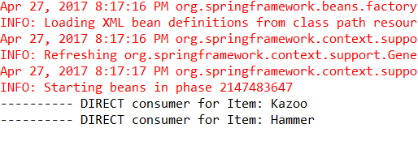

**NOTE: You could start by adding a consumer to AMPQProducer.zip for testing/debug**